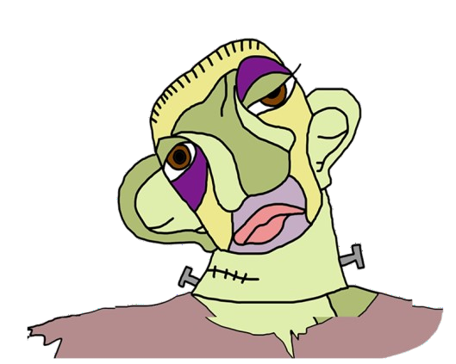MONSTERS

|  |  |  |  |
| --- | --- | --- | --- |
|  | **THE MONSTER**  **OF VICTOR FRANKENSTEIN** | **QUASIMODO** | **THE ELEPHANT MAN** |
| **REAL PERSON OR CHARACTER ?** | Character | Character | Real person |
| **WHO CREATED HIM?** | Mary Shelley | Victor Hugo | ------------------------ |
| **WHEN ?** | 1st March 1818 | 1831 | ------------------------- |
| **BOOK HE BELONGS TO** | Frankenstein | The Hunchback of Notre- Dame | ------------------------- |
| **HIS PROBLEM** | He was a bit selfish and ended up being left alone and turned into a monster. | He was deformed and in love with a girl who was already in love with another man | He feels very lonely because people let him out of the band |
| **COULD HE BE HAPPY?** | No | Yes but not all the story. | Yes and no at the final. |
| **HOW DID HIS LIFE END?** | He did not like the things he did and took his own life | He die. | He die. |