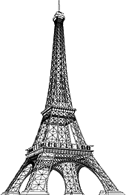

***Paris in the Belle Époque***

**Paris in the Belle Époque was a period in the history of the city between the years 1871 to 1914, from the beginning of the Third French Republic until the First World War.**

**It saw the construction of the Eiffel Tower, the Paris Métro, the completion of the Paris Opera, and the beginning of the Basilica of Sacré-Cœur on Montmartre.**

**Three "universal expositions" in 1878, 1889 and 1900 brought millions of visitors to Paris to sample the latest innovations in commerce, art and technology.**

**Paris was the scene of the first public projection of a motion picture, and the birthplace of the Ballets Russes, Impressionism and Modern Art.**

**The expression Belle Époque ("beautiful era") came into use after the First World War; it was a nostalgic term for what seemed a simpler time of optimism, elegance, and progress.**

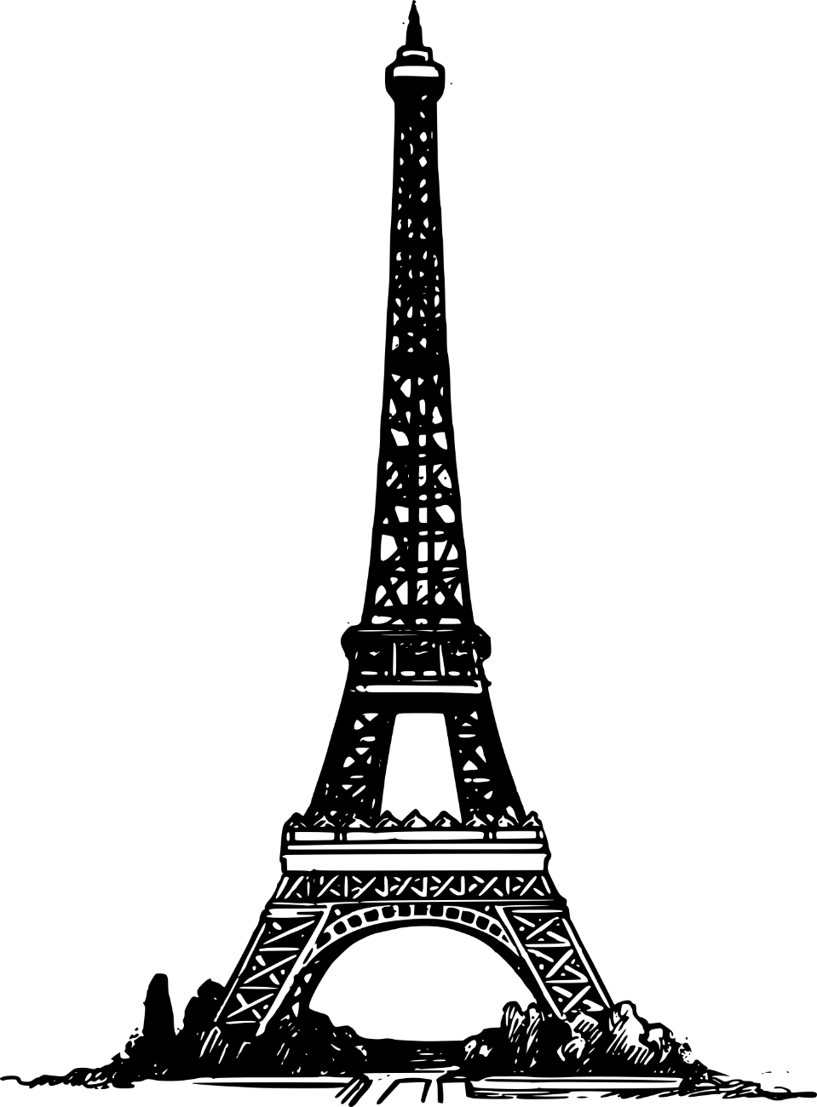

1. **THE OPERA HOUSE**
2. **THE EIFFEL TOWER**
3. **THE SACRE COEUR**
4. **NOTRE DAME**
5. **THE PANTHEON**
6. **ARC DE TRIOMPHE**
7. **LES INVALIDES**
8. **MUSÉE DE CLUNY**
9. **PLACE RÉPUBLIQUE**
10. **CEMETERY PÈRE LACHAISE**

**WHY ARE THESE PLACES IMPORTANT? JUST WRITE A SIMPLE SENTENCE EXPLAINING WHY THEY ARE SO FAMOUS ALL OVER THE WORLD.**

SPOT THE FOLLOWING PLACES ON THE MAP AND MARK THEM.

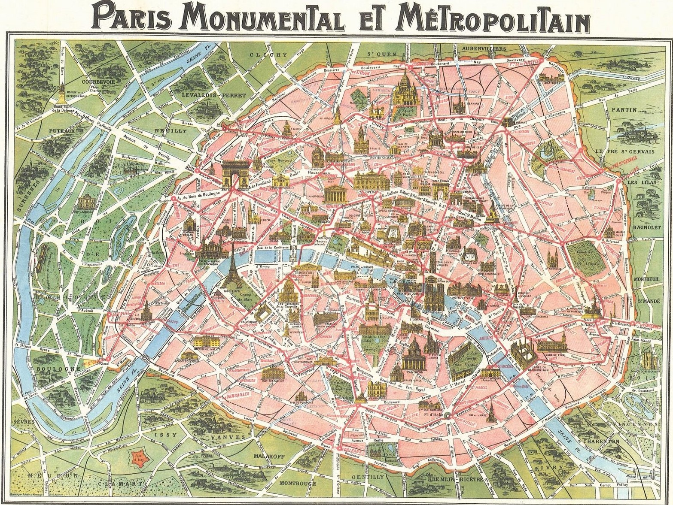

**WHY ARE THESE PLACES IMPORTANT?**

**1. THE OPERA HOUSE:** The Opera Garnier or Palais Garnier is one of Paris' most celebrated monuments. Situated in the 9th arrondissement at the end of the avenue de l'Opéra, the sumptuous opera house symbolises the opulence of the Second Empire.

**2. THE EIFFEL TOWER:** The Eiffel Tower, La Tour Eiffel in French, was the main exhibit of the Paris Exposition of 1889. It was constructed to commemorate the centennial of the French Revolution and to demonstrate France's industrial prowess to the world.

**3. THE SACRE COEUR:** Is a Roman Catholic church and a famous landmark in Paris with a deep and complex history as it is not only a religious monument but also a political one.

**4. NOTRE DAME :** Notre-Dame de Paris is cathedral church in Paris. It is the most famous of the Gothic cathedrals of the Middle Ages and is distinguished for its size, antiquity, and architectural interest.

**5. THE PANTHEON :** **I**s the most preserved and influential building of ancient Rome. It is a Roman temple dedicated to all the gods of pagan Rome.

**6. ARC DE TRIOMPHE :** It honours those who fought and died for France in the French Revolutionary and Napoleonic Wars, with the names of all French victories and generals inscribed on its inner and outer surfaces.

**7. LES INVALIDES :** Because of its location and significance, the Invalides served as the scene for several key events in French history.

**8. MUSÉE DE CLUNY**: It has thousands of works from between the 3rd and 16th centuries, including a magnificent exhibition of tapestries, sculptures, stained glass, goldsmiths, jewellery and ivories.

**9. PLACE RÉPUBLIQUE :** The Place de la Republique is the spot where the 3rd, 10th and 11th district come together. It is a major venue for social gatherings because of its location, but mostly its symbolism, as it is centered around the imposing Statue of the Republic.