The Mask of the Red Death
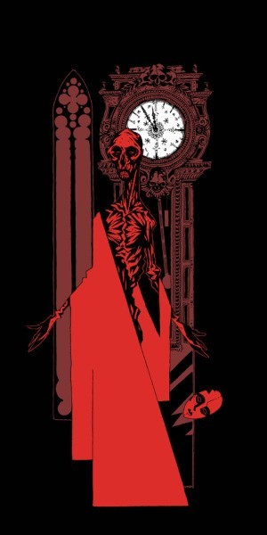A terrible disease called the Red Death has struck the country. It is incredibly fatal, horribly gruesome, and it has already killed off half the kingdom. But the ruler of these parts, Prince Prospero, does not seem to care about his poor, dying subjects. Instead, he decides to let the kingdom take care of itself while he and a thousand of his favourite knights and ladies shut themselves up in a fabulous castle to have one never-ending party. Wine, women, music, dancing, fools— Prospero's castle has it all. After the last guest enters, no one else can get in—the Prince has welded the doors shut. That means no one can get out, either…

About five or six months into his stay, Prospero decides to have a spectacular masquerade ball (a ball where the guests wear masks and costumes). The
setup is weird and wild, just like the Prince who designs it. The ball takes place in a suite of seven rooms, each one dressed up in a different color: blue, purple, green, orange, white, violet, and black. The black room, which
looks like death, is awfully creepy—it is got dark black walls, blood red windows, and big black clock which chimes so eerily every hour that everybody at the party stops dancing and laughs nervously. Most of the frolicking masqueraders are too weirded out to go into the black room.

Anyway, the party's in full swing and everybody is having a wild time when the clock strikes midnight. Everyone stops dancing and falls momentarily silent, as usual. Then some of the dancers notice a guest no one had seen before, wearing a scandalous costume. Whoever the new guest is, he's decided to dress as a corpse, a corpse who died of… the Red Death. He's so frighteningly lifelike (deathlike?) he freaks everybody out, and he slowly starts "stalking" through the frightened crowd. When Prince Prospero sees the ghostly guest, he's furious that someone would have the nerve to wear such a costume and orders him to be seized and unmasked. But no one has the guts to do it, including Prospero himself.
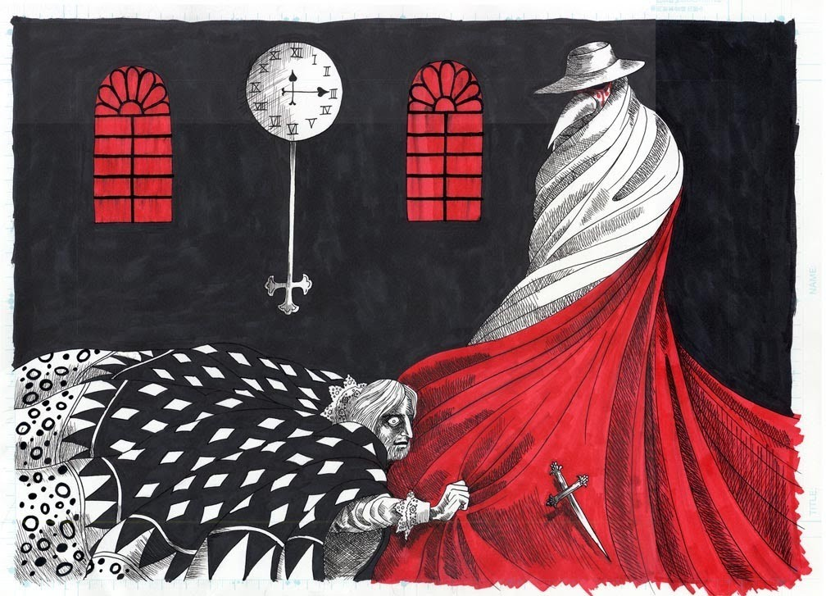
The Red Death masquerader passes within a few feet of the Prince and starts to walk through the rooms, heading toward the black room. Prospero loses it and runs after him in a rage, drawing his dagger as he approaches. But just as Prospero reaches the edge of the black room, the corpselike guest suddenly whirls around to face him, and Prospero falls to the ground, dead. The shocked crowd throws itself at the guest, only to discover in horror that there is nothing underneath the mask and costume. The Red Death itself has come to the party. One by one the guests die, spilling their blood all over Prospero's lavish rooms. The candles go out, leaving only "darkness, decay, and the Red Death."

1/ VOCABULARY
WRITE THE WORDS IN YELOW AND LOOK UP THEIR MEANING IN THE DICTIONARY.

1 | gruesome | causing repulsion or horror
2 | subjects | a person or thing that is being discussed, described, or dealt with.
3 | guests | a person who is invited to visit someone's home or attend a particular social occasion.
4 | masquerade | a false show or pretence.
5 | Weird and wild | extravagant
6 | creepy | causing an unpleasant feeling of fear or unease.
7 | frolicking | play or move about in a cheerful and lively way.
8 | In full swing | at the height of activity.
9 | A corpse | a dead body, especially of a human being rather than an animal.
10 | Freaks everybody out | Become or cause someone to become extremely emotional.
11 | seized | take hold of suddenly and forcibly.
12 | heading | a title at the head of a page or section of a book.
13 | rage | violent uncontrollable anger.
14 | lavish | sumptuously rich, elaborate, or luxurious.
15 | decay | rot or decompose through the action of bacteria and fungi.

2/ THE STORY

PROSPERO MAKES A HUGE MISTAKE. WHIICH ONE?
He believes he can avoid death.
- WHY IS A CLOCK SO IMPORTANT IN THIS STORY?
Because it has a very important relationship with death.
- WHICH MORAL CAN BE LEARNED FROM THE STORY?

"Avoid" the confrontation with death.

