**The Phantom of the Opera:**

**​Physicall description:**

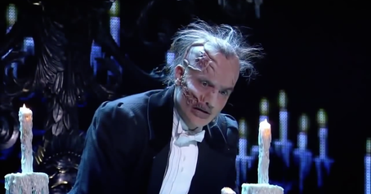He has no face, yellow skin, he doesn’t have beard. He is Square-faced and he's very pale. The Phantom wears a black cape, which adds a sense of mystery to his persona, symbolic of hiding who he really is. He is also physically deformed.

**Personality description:**

Is a secretive, passionate, and controlling character. A musical genius, the Phantom may hide in the walls of the Opera House, but he's certainly pulling its strings. Though generally a quiet poltergeist, he's willing to be more malevolent when he wants something.